Title Page

Title of the Manuscript

Proximate Composition of Nappi and its way of marketing in Bangladesh.

Md. Mostafa Monwar1*, Md. Royhanur Islam1, Sawmor Dey Nirjar2, Mohammed Ashraful Azam Khan2, Mohammed Shahidul Alam2, Ataher Ali2 and Istiak Ahmed1

1 Institute of Marine Sciences, University of Chittagong, 4331 Chattogram, Bangladesh

2 Department of Fisheries, University of Chittagong, 4331 Chattogram, Bangladesh

* Corresponding Author: monwar@cu.ac.bd

Title of the Manuscript

Proximate Composition of *Nappi* and its way of marketing in Bangladesh

**Abstract**

*Nappi*, fermented shrimp, a traditional diet, is widely consumed by the ethnic communities of Southeast Asian countries, especially in Bangladesh. The present study was carried out to determine the proximate composition of *Nappi* collected from two different places i.e., Maheshkhali and Chaufaldandi areas of Cox’s Bazar district, Bangladesh. The proximate composition of *Nappi* was varied from place to place depending on raw materials, preparation techniques and surrounding conditions of formulation places. Proximate composition includes moisture, protein, carbohydrate, fat and ash contents, amounting 37.66±1.51%, 37.23±1.78, 1.39±0.10, 6.00±0.40% and 18.46±0.59% respectively for the Maheshkhali and 35.44±1.37%, 37.23±1.78%, 2.66±0.21%, 6.00±0.40%, and 18.46±0.59% respectively for the Chaufaldandi sample. In the present study it was evident that moisture and fat content were significantly higher (ANOVA, p < 0.05) in Maheshkhali sample whereas protein, carbohydrate and ash content were significantly higher (ANOVA, p < 0.05) in Chaufaldandi sample. Marketing strategy, Supply Channel, and Value Chain of *Nappi* were also analyzed. The findings of the study revealed that the good quality of *Nappi* relied on the fresh raw materials, hygienic condition of processing place and suitable techniques. Moreover, the good quality *Nappi* has a great market demand to the local ethnic communities in Bangladesh as well to the ethnic communities are living abroad. So, it is recommended to provide intervention on proper preparation techniques and marketing channels of *Nappi.*

**Keywords:** *Nappi*, ethnic community, commercialization, techniques, seasonal product,

fermented shrimp, Bangladesh

**1. Introduction**

Bangladesh is a South Asian nation renowned for its historical, cultural, and traditional wealth. Food is one of the most remarkable aspects of Bangladesh. Consisting of an assortment of spices and flavors, Bangladeshi cuisine is among the most singular and diverse in the world. Bangladesh possesses an extensive culinary heritage and historical background in the realm of cuisine. The cuisine of the nation has been influenced by its climate, geographical location, and cultural diversity. Bangladeshi cuisine has been shaped by numerous cultures, such as that of the Portuguese, the Mughals, and the British.

Each nation has a variety of characteristics that set it apart from the rest of the world. This distinctiveness is something the nation takes pride in displaying, encompassing its historical background, populace, and cultural practices. Traditional Bangladeshi cuisine consists of a combination of *charchari* (dry curry), *dal* (lentil soup), *vaji* (fried), *bhorta* (mashed), *torkari* (cooked), and *bhorta* (mashed) prepared with locally or seasonally available meat, fish, and vegetables. Potatoes, cauliflower, cabbage, tomatoes, beans, peas, carrots, radishes, pumpkins, eggplants, bitter gourds, and various others are typical vegetables [1]. Numerous well-known fish species can be found in the area, such as the bombay duck (*Harpadon nehereus*), rui (*Labeo rohita*), catla (*Gibelion catla*), mola (*Amblypharyngodon mola*), tengra (*Mystus tengara*), kachki (*Corica soborna*), puti (*Puntius sophore*), taki (*Channa punctata*), and a host of others [1].

In anthropological literature, the term "ethnic group" is commonly defined as a population (Naroll, [2]) that satisfies the following criteria: (1) is predominantly self-sustaining biologically; (2) manifests overt unity in cultural expressions; (3) constitutes a domain of communication and interaction; and (4) possesses a membership that is recognized by others as constituting a distinct category from other categories of the same other. Ethnic communities vary in terms of identity, culture, organization, way of life, language and culture, food and dress patterns, housing arrangements, leadership structures, social and village organization, ceremonial ceremonies involving children and the deceased, and religious and social celebrations. Although the majority of them reside in hilly regions, they have made recent efforts to adapt to globalization, mainstream commerce, and language, among other things [3].

There are typically two distinct ethnic groups residing in Bangladesh, categorized by geography. There are those who inhabit steep terrain and those who reside in plains. A segment of this population resides in the Chattogram Hill Tracts, specifically in the south-eastern regions, namely Rangamati, Bandarban, and Khagrachhari [4]. These districts are inhabited by the *Chakma, Marma, Tripura, Mru, Tanjanga, Bawm, Pangkhua, Chak, Khang, Khumi*, and *Lusai* minority ethnic groups. Both biologically and structurally, they closely resemble the Mongolian people. These individuals are also referred to as "Hill people." Anthropologically speaking, Mongolians also inhabit the northeastern region of Bangladesh. The *Garo, Hajang,* and *Coach* are notable ethnic minority groups who reside in the vicinity of Mymensingh. Greater Sylhet is home to the *Khasi* or *Khasia* and *Monipuri* minority ethnic groups. Additionally, *Rakhain*, an ethnic group associated with the Morgue people, inhabit the districts of Cox's Bazar, Patuakhali, and Barguna. Small ethnic groups include *Saontal, Orao, Mahali, Monda, Malpahary*, and *Malo* inhabit the northwestern regions of Bangladesh, including Dinajpur, Rangpur, Rajshahi, Bogura, and Pabna, among others. They are referred to as dwellers of plain land. They also live in greater Sylhet. Some more minority ethnic groups of people live in Bangladesh [4]. *Dalu, Hodi, Rajbangshi, Patro, Barman, Banai, Pahan, Mahato, and kol* are a few examples. Additionally, they inhabit several regions of Gazipur, Mymenshing, larger Sylhet, and Tangail [5].

The indigenous population resides primarily in the hilly regions of Chittagong. Communities are socioeconomically, politically, and socially separate groups of individuals. In Bangladesh, they are alternatively referred to as Tribal People, Ethnic Group, or Minorities. The indigenous people's way of life and culture are extraordinarily intriguing. They are Buddhist in origin. Additionally, there are Christian, Hindu, and animist communities. Primitive ways of life are also prevalent within the majority of the ethnic group. Overall, women engage in more labor-intensive endeavors than men [6].

The indigenous people are exceptionally self-reliant. They choose to live an extremely basic existence. Conversely, they manufacture the vast majority of daily necessities, such as clothing and food. The majority of tribal people are bilingual in their native tongue and the state language (dialect). As to the communities' assertions, they observe unique ceremonies and rituals. They, too, wear unique attire. The ladies possess a variety of unique abilities, such as weaving fabrics, preparing community-specific traditional dishes, and observing their own culture. Overall, they live a modest existence and are benevolent and welcoming. Under every critical circumstance, they proceed in unison.

It is crucial to keep in mind that the Statistics Bureau classifies Bangladesh into 27 distinct tribal groups [7]. They currently reside in the Sylhet Division, Rajshahi Division, Chittagong Hill Tracts, and Mymensingh District. In Bangladesh, the Chakma constitute the largest ethnic group, while the Marma rank second in size. There are approximately two million people officially recognized ethnic minority groups in Bangladesh [7]. They constitute approximately 1.25 percent of Bangladesh’s population. There are two broad categories of ethnic minorities in Bangladesh: groups that reside in the Chittagong Hill Tracts (CHT) in the southeastern Chattogram Division, and groups that reside in the northern divisions, often referred to as plainland ethnic groups [7]. For them, fish and fishery-related activities are one of the main sources of income that contributes towards their daily needs and survival.

Note that,fish and fishery products are consumed on a global scale for their nutritional value. The freshness of fish is the primary determinant of its nutritional value. The commencement of decomposition results in a reduction in the nutritional value of fish. Fish should therefore be handled without interruption. The bulk of indigenous inhabitants in Bangladesh, nevertheless, do not have access to refrigerated facilities. Consequently, preservation techniques are implemented, including temperature reduction (e.g., boiling or frying), moisture dehydration (e.g., smoking, drying, and salting), and pH reduction (via fermentation). These procedures have the potential to induce modifications in the flavor and consistency of the fish, in addition to yielding distinctive fishery products.

In Bangladesh, locally processed fermented fish-derived, so called “*Nappi*”, is a daily essential ingredient in cooking many dishes of the tribal people who lives in the southeast and west parts of this country and also the tribe in the neighboring country in Myanmar. The indigenous salty food ‘*Nappi*’ is specially made by Rakhine, an ethnic tribal community of hill track districts in Bangladesh includes coastal areas such as - Cox’s Bazar, Teknaf, Chaufaldandi, Maheshkhali, and Patuakhali. *Nappi* is a very popular traditional fermented fishery product which is semi solid shrimp paste with potent flavor. This popular indigenous cuisine is also known with diverse names in different countries i.e., *Nappi* in Bangladesh, *Terasi* in Indonesia, *Ngapi* in Myanmar, *Kapi* in Thailand, *Ki* in Cambodia, *Blacan* in Malaysia and *Bagoong* in Philippines [8, 9, 10, 11, 12]. It is thought that this shrimp paste was first made in the Southeast Asia probably by the Cham and Mon peoples of the Indo-China region [12, 13].

Generally, shrimps are used to produce fermented paste named *Nappi*. Shrimps of the genera *Acetes*, (small krill like prawns), Mesopodopsis, Lucifer, and Mysids are usually use to make this product. The genus *Acetes* is the most common raw materials to produce shrimp paste and other fermented products. Typically, small shrimps such as *Acetes sp* and *Mysid sp* are mainly used to make *Nappi* in Maheshkhali and Chaufaldandi of Cox’s Bazar district, Bangladesh. Sometimes a small amount of fish fry, fingerling and small fish are also mixed with raw material which is locally known as “*Meng*” in Maheshkhali. Shrimp species used to produce this food varies country to country, depending on the types of shrimp availability in that specific country. In Southeast and East Asian countries, Acetes shrimp species are the most abundant and commonly used to produce fermented shrimp products, in which *A. indicus*, *A. erythraeus*, *A. vulgaris* and *A. japonicus* are the most common.

*Nappi*, a traditional and widely consumed fermented fishery product, is primarily produced by the *Rakhaing* of hill districts (specifically Chittagong and Chittagong hill tracts) and coastal areas (including Cox's Bazar, Teknaf, Barguna, and Patuakhalli) in Bangladesh. Among the ethnic community, *Rakhaing* are the most well-known producers and vendors of *Nappi*. *Nappi,* a fermented semi-solid fish paste characterized by its robust flavor, serves as an affordable protein source for an economically disadvantaged and underprivileged ethnic population in Bangladesh.

*Nappi* is highly regarded by the inhabitants of the hill regions. *Nappi* is utilized by individuals to enhance the flavor of their dishes. This is *chepa shutki* in another form. *Nappi*, which is used to dishes, is encased in banana tree leaves and torched until it becomes rigid. It may also be utilized in cooking directly after being combined with water. With the exception of the three hill tract districts, Chattogram, Barisal, Barguna, and Patuakhali all place significant significance on *Nappi*. Through Teknaf and the Chittagong Hill Tracts, *Nappi* is exported monthly to Myanmar and India. Numerous restaurants in Thailand, Indonesia, and Sri Lanka have begun to offer *shutki* staples such as *Nappi*.

According to some research it provides Moisture: 35.40%, Protein: 32.0%, Fat: 12.0%, Ash: 18.9%, pH: 6.2 [14], 38.35% protein, 20.31% fat with antioxidant activity, and health beneficial bioactive compounds [15]. Fish fermentation increases the bioavailability of minerals and provides excellent organoleptic qualities to the product [16]. Fatty acid content is considerably lower in fermented fish as opposed to fresh fish [17]. It has been discovered that fermented fish oil is exceptionally rich in EPA (Eicosapentaenoic Acid) and DHA (Docosahexaenoic Acid) [18]. Han et al., [18] reported that fermented fish oil contains DHA which can help alleviate the symptoms of atopic dermatitis. Fermented fish also contains natural antioxidants and essential nutrients. It has been reported that bioactive peptides derived from fermented fish products act as antioxidants[19]. Shivanne Gowda et al., [20]emphasized that, depending on their amino acid sequences, bioactive peptides may exert a variety of biological effects, including antioxidant, antagonist, antihypertensive, immunomodulatory, and anticancer action. Fermented shrimp paste contains fatty acids, amino acids including aspartate, glutamate, alanine, leucine, lysine, arginine, and proline [21]. Like as, *Nappi* also contains high amino acids, protein, minerals and polypeptides [9, 22]. The nutritional value of fermented shrimp or *Nappi* basically depends on manufacturing procedures or processing techniques, handling, the quality of raw material and processing place [9]. It has a chance of contamination with some bacteria, fungi, viruses and parasites if there are unhygienic conditions, poor preparation techniques and spoiled raw shrimps [6, 13]. As it has a higher nutrient contents and high demand to the ethnic community, this food product can be taken to the potential international market in Myanmar, Indonesia, Thailand, China, Hongkong and Malaysia, if quality is ensured.

**2. Materials and Methods**

**2.1 Study area**

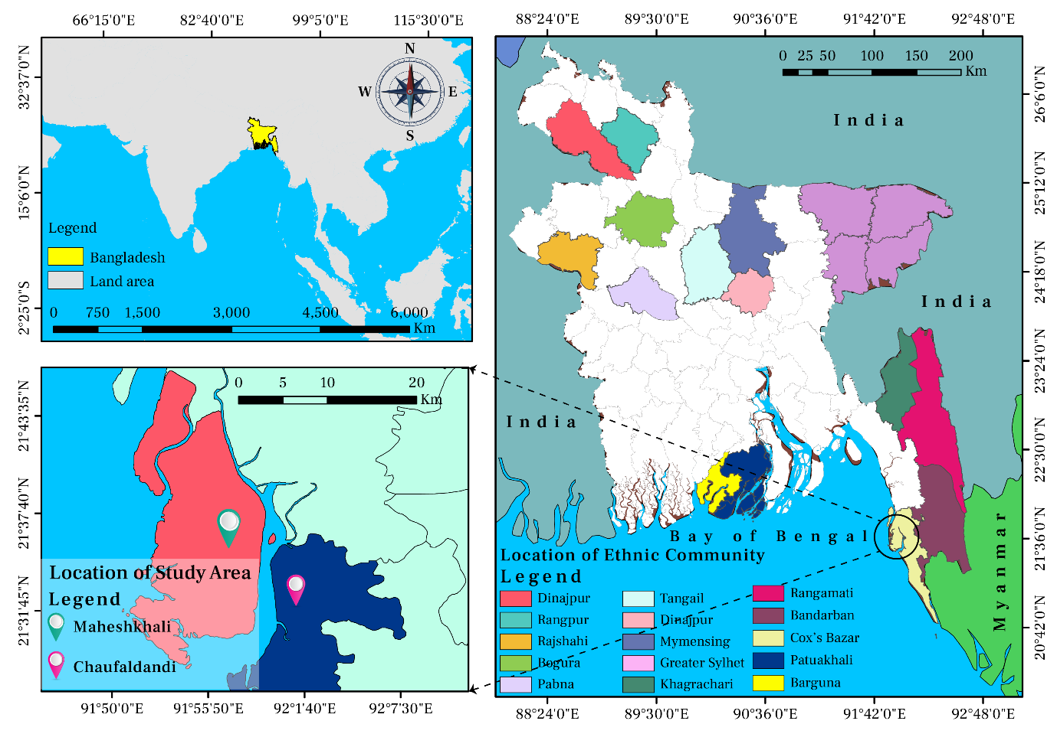

**Fig 01:** Map showing the location of ethnic communities in Bangladesh (right side) and the location of study area (below of left side).

**2.2 Sample collection**

*Nappi* samples were collected from Maheshkhali and Chaufaldandi areas of Cox's Bazar, Bangladesh. The samples were collected from the villagers in those areas involved in the preparation of *Nappi*. It is during the winter season when the local indigenous community prepares the *Nappi.* December 2022 was the date when the study sample was collected. Collected samples were packed into an airtight container and brought immediately to the laboratory of the Institute of Marine Sciences, University of Chittagong, Bangladesh. A total of 100 samples were macerated in a motor with a pestle separately and used to determine the proximate composition of the sample. Three replicates were used for each analysis. A standard procedure was followed to determine protein [23, 24, 25], fat [24, 26], carbohydrate and ash [26], and moisture [27, 25] of *Nappi*. The study includes information about *Nappi* preparation based on discussions with the producers. In addition, the marketing channel analysis was conducted through discussions with producers, sellers, and buyers.

**2.1.1 Preparation of *Nappi***

Raw materials include trash fishes, by catch species as well as undesirable species with no commercial importance were collected from the fishermen (A representative example of raw materials is shown in Figures 1 and 2).

|  |  |
| --- | --- |
|  |  |
| **Figure 1**. Specimen used for Nappi preparation (*Acetes sp)* | **Figure 2**. Specimen used for Nappi preparation (*Mysid sp)* |

Collected raw materials were then graded on the basis of their sizes. Small amount of salt was added with raw materials (Fig 3.A). Then these were dried in the sun for 1-2 day (Fig 3.B). After sun drying raw materials were grinded in wooden mortar with salt (Fig 3.C). The grinding raw materials dried again in

**A. Sorted & salted raw shrimp**

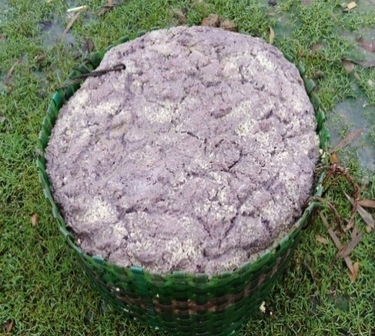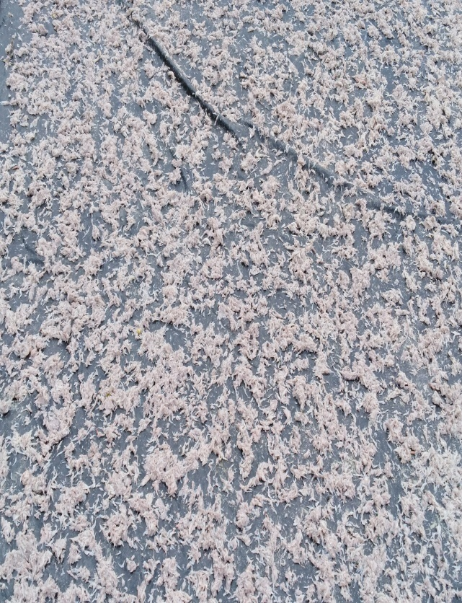

**B. Sun drying salted shrimp**

**C. Mortar-pestle for grinding**

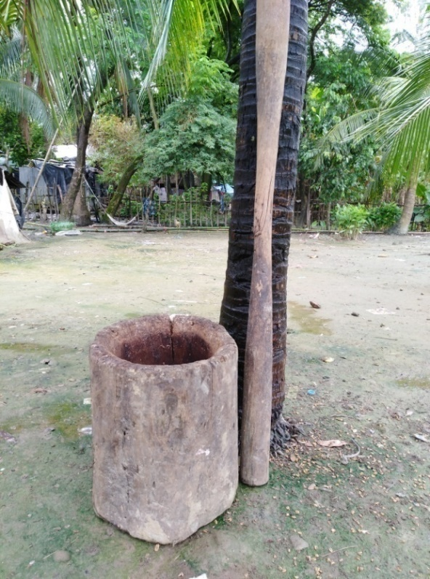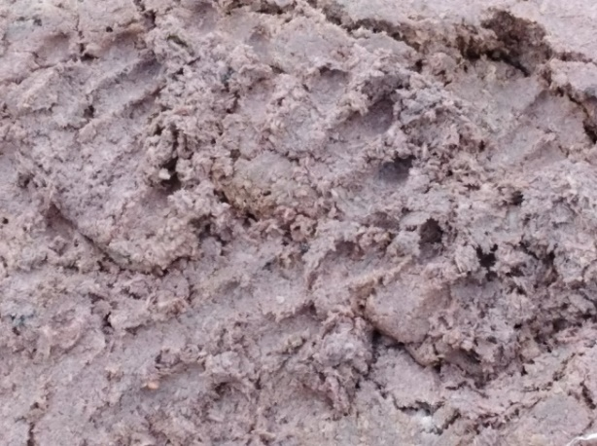

**D. Grinded salted shrimp**

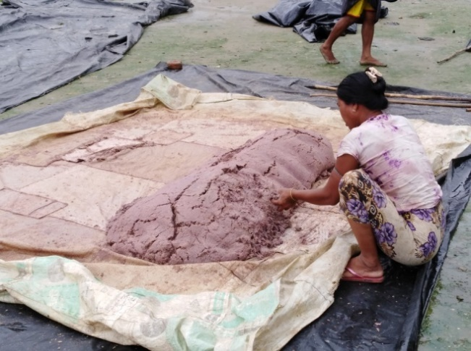

**E. Quality checking of *Nappi***

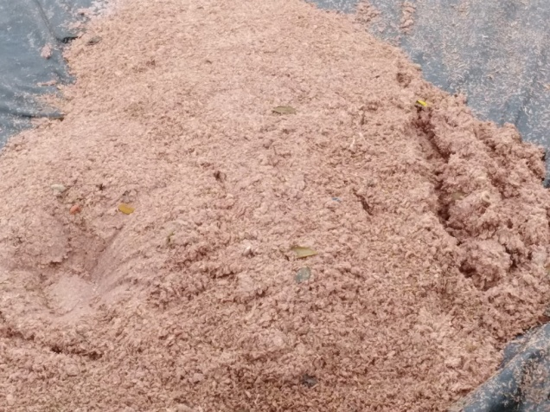

**F. *Nappi* ready for marketing**

**Figure 3.** (A-F) Traditional methods of *Nappi* preparation. A. raw materials sorted and salt added, B. Sun drying to the salted raw materials; C. Used mortar pestle for raw materials grinding; D. Grinded raw materials by mortar; E. Checking the quality of nappi; F. Nappi ready for further applications the sun and then grinded in wooden mortar with salt (Fig 3.D). Finally, the paste product was ready for packaging and selling (Fig 3.E & 3.F). *Nappi* preparation is clearly depicted in Figure 3. *Nappi* is exclusively prepared by indigenous communities in Bangladesh in accordance with their traditional methods and within their local environment.

**4. Statistical Analysis**

For all proximate compositions (Protein, Fat, Ash, Moisture, Carbohydrate) ten replicates were done (n=10) in the lab and the obtained data is expressed as mean ± standard deviation (mean±SD). All the statistical analysis was conducted by r-programming (Version: 4.2.3). Graphs were produced by using r packages named as ggplot2 (version: 3.4.4) and PerformanceAnalytics (Version: 2.0.4). Data of two different sampling station was analysed by one-way analysis of variance (ANOVA) and Tukey as post hoc test i.e. difference between the same proximate composition (i.e. Protein) of two different sampling station (Maheshkhali and Chaufaldandi) with the significance difference level of p < 0.05.

**5. Results and Discussion**

**5.1 Proximate Composition of *Nappi***

The percentage of protein, fat, moisture, ash and carbohydrate of *Nappi* from Maheshkhali and Chaufaldandi were 34.34±0.68%, 8.53±0.45%, 37.66±1.51%, 17.49±0.46 % and 1.39±0.10% (Table 1) and 37.23±1.78%, 6.00±0.40%, 35.44±1.37%, 18.46±0.59% and 2.66±0.21% respectively (Table 1).

Table 1: Proximate composition of *Nappi* collected from two sites (Maheshkhali and Chaufaldandi).

|  |  |  |  |  |  |
| --- | --- | --- | --- | --- | --- |
| **Proximate composition⇨**  **Station⇩** | **Moisture (%)** | **Protein (%)** | **Ash (%)** | **Carbohydrate (%)** | **Fat (%)** |
| (Mean±SD) | (Mean±SD) | (Mean±SD) | (Mean±SD) | (Mean±SD) |
| Maheshkhali | 37.66±1.51 | 34.34±0.68 | 17.49±0.46 | 1.39±0.10 | 8.53±0.45 |
| Chaufaldandi | 35.44±1.37 | 37.23±1.78 | 18.46±0.59 | 2.66±0.21 | 6.00±0.40 |

Furthermore, a comparative study of proximate value was conducted between the two sites (Fig 5). The study revealed that the average crude protein content from both areas. Despite the low moisture content in the samples, Chaufaldandi had a higher crude protein concentration than Maheshkhali.

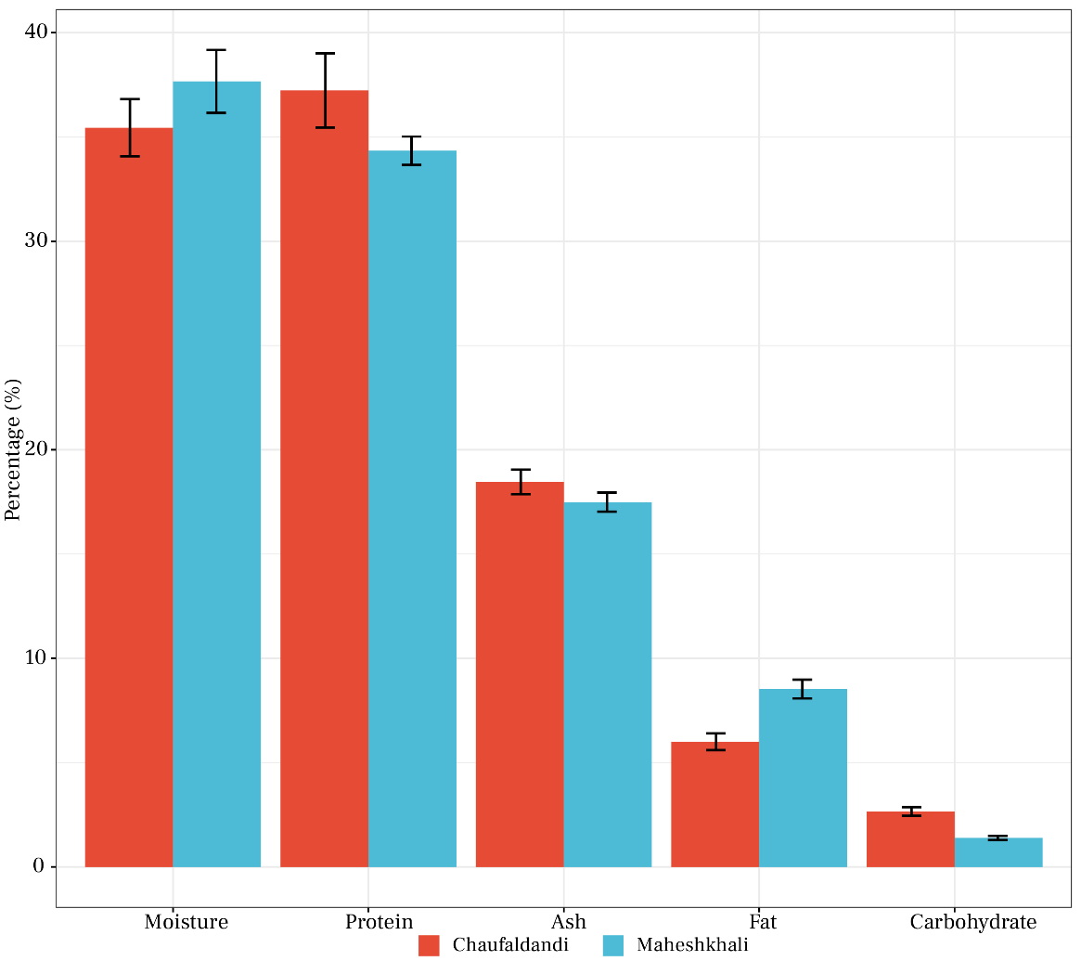

**Figure 5.** Bar graph showing the comparison of Nutritional profile (Moisture, Protein, Ash, Fat and Carbohydrate) of collected *Nappi* samples among two different study sites (Maheskhali and Chaufaldandi). Data shown are the mean±SD (n = 10).

There is a slight positive correlation of protein in the sample of Maheshkhali sample with ash and carbohydrate (r = 0.48 and 0.31), and negatively altered with moisture and fat content (r = -0.44 and – 0.33) in a similar way (Fig 7). On the contrary, the protein in Chaufaldandi sample showed a less positive relationship with ash and carbohydrate (r = 0.36 and 0.16) than that of Maheshkhali (Fig 7). Howeve, a higher negative relation than all is observed in the ash and fat content of Chaufaldandi sample.

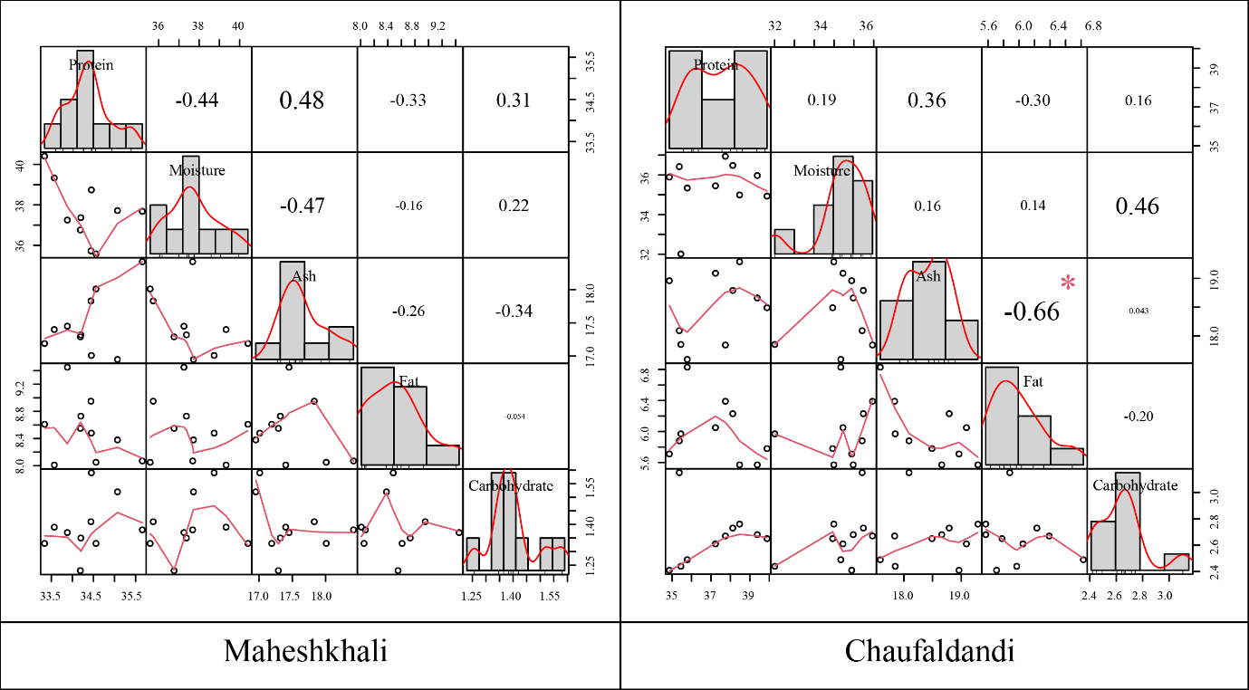

**Fig 07:** Correlation plot of proximate composition of two different location showing the relationship among the proximate composition.

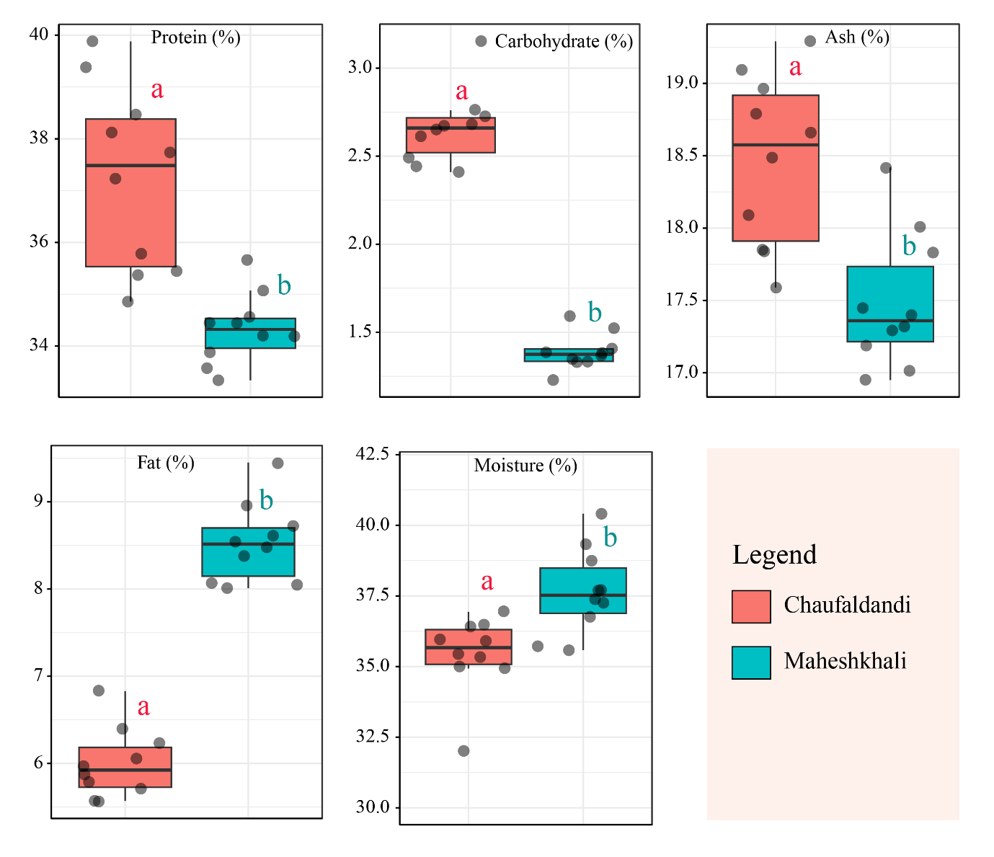

**Fig 6:** Percentage of proximate composition from two different location (Maheshkhali and Chaufaldandi). Different letters above the boxplot depicts significant diference (ANOVA, P < 0.05) between same proximate composition of two different location with ten observation each (n = 10).

Protein, carbohydarate and ash percentage in Chaufaldandi sample were found to be significantly higher (F(1) = 22.97, 295.7, and 16.95; p = 0.0001, 0.0000, and 0.0006) compared to the Maheshkhali sample wherase moisture and fat content were statistically higher (F(1) = 11.73, and 178.9; p = 0.0030 and 0.0000) in the sample of Maheshkhali (Fig 6, Table 2).

Table 2: Statistical summary of Tukey SHD and ANOVA for same proximate composition of two different location (Maheshkhali and Chaufaldandi).

|  |  |  |  |  |  |  |  |
| --- | --- | --- | --- | --- | --- | --- | --- |
| **Statistical test ⇨**  **Variables⇩** | **Tukey SHD result** | | | | **ANOVA result** | | |
| **Diff.** | **Diff.**  **Lower** | **Diff.**  **Upper** | **P value** | **df** | **F value** | **P value** |
| Protein | - 2.892 | -4.160 | -1.624 | 0.0001 | 1 | 22.97 | 0.0001 |
| Carbohydrates | -1.269 | -1.424 | -1.114 | 0.0000 | 1 | 295.7 | 0.0000 |
| Ash | -0.978 | -1.477 | -0.479 | 0.0006 | 1 | 16.95 | 0.0006 |
| Fat | 2.530 | 2.133 | 2.927 | 0.0000 | 1 | 178.9 | 0.0000 |
| Moisture | 2.215 | 0.856 | 3.574 | 0.0030 | 1 | 11.73 | 0.0030 |
| *\*Diff = Difference, P value = Probability value, df = Degrees of freedom, F value = F statistics* | | | | | | | |

It is noteworthy that these protein content values are similar to those reported by relevant studies such as those conducted by Clucas and Ward [28], who reported that *Nappi* contains a crude protein content of 30% to 40%. In Mau [29], it was reported that the crude protein content of *Nappi* ranged between 22.62% and 33.46%. Based on the results of (Kim et al., [9], the protein content of Bruneian and Korean shrimp paste ranges between 30.38 % and 21.70 %.

In the samples collected from Maheshkhali and Chaufaldandi, the fat content was 8.53% and 6%, respectively. According to the study, the fat content is similar to that of Mau [29]. Depending on the source, Mau [29] found that the fat content ranged from 5.58% to 12.53%. According to Mau [29], the fat content ranged between 5.58 and 12.53%. A study conducted by Gavino et al., [30] reported a fat content of 0.91 percent in *Acetes sp* from Philippines.

It is important to note that the fat content of *Nappi* is dependent on the raw materials, and low values may be observed because the main components were *Acetes* and *Mysids* shrimp, both of which are low in fat. A percentage of 37.66% and 35.44% of moisture was recorded in Maheshkhali and Chaufaldandi, respectively. *Nappi* has a moisture content between 27% and 40% according to Clucas and Ward [28]. In traditional *Belacan* and *Cincalok* shrimp paste from Malaysia, Huda-Faujan et al., [31] found moisture contents ranging from 32.16-67.44%. As observed in Chaufaldandi, the amount of ash in the *Nappi* was higher (18.47%) than that observed in Maheshkhali (17.49%), which agrees with Clucas and Ward [28] and Huda-Faujan et al., [31]), who reported higher levels of ash, 20-24%, and 43.97-56.15% respectively. It is important to note that, name of the fermented food staffs varies according to the country [32]), and the information are framed in Table 1.

**Table 1.** Shrimp species and fermented shrimp paste that are available in South and Southeast Asia

|  |  |  |
| --- | --- | --- |
| **Country** | **Shrimp Paste Name** | **Shrimp Species** |
| Bangladesh | *Nappi* | *A. indicus, A. vulgaris* |
| Myanmar | *Nga-pi, Seinsa* | *A. indicus, A. vulgaris, A. intermedius* |
| Thailand | *Kapi* | 1. *japonicus* |
| Indonesia | *Terasi, Udang* | *A. japonicus, A. sibogaesibagae* |
| Malaysia | *Belacan* | *A. japonicus, A. erythraeus, A. sibogaesibagae* |
| Philippines | *Bagoong, Alamang, Dinailan* | *A. erythraeus, A. intermedius, A. vulgaris* |

Source: [32])

**3.2 Marketing, Supply Channel and Value Chain of *Nappi***

Market channels are the routes along which products flow from producers to consumers [33]. Processes and activities related to producing a product and delivering it to a target market are considered to be part of the supply chain. Several market intermediaries were involved in the supply chain of *Nappi* between producers and the final consumers, including local traders, traders, commission agents, wholesalers, and retailers. A diagram illustrating *Nappi*'s distribution and supply chain with two flows: major and minor flows, is depicted in figure 7.

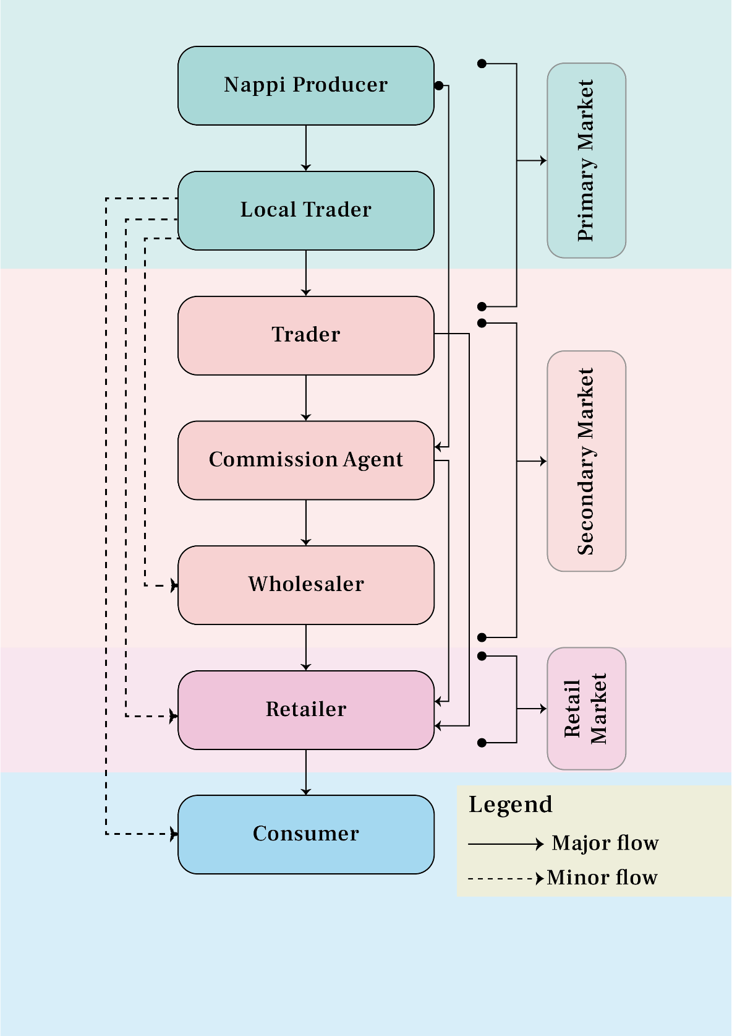

**Figure 7.** Distribution and supply chain of *Nappi* in Bangladesh

The supply of *Nappi* is distributed through a number of different marketing channels in both study areas, whereas only a few marketing channels account for a significant portion of the supply. In the field study, it was identified that four channels would be considered for the marketing of *Nappi* in Bangladesh (Figure 8).

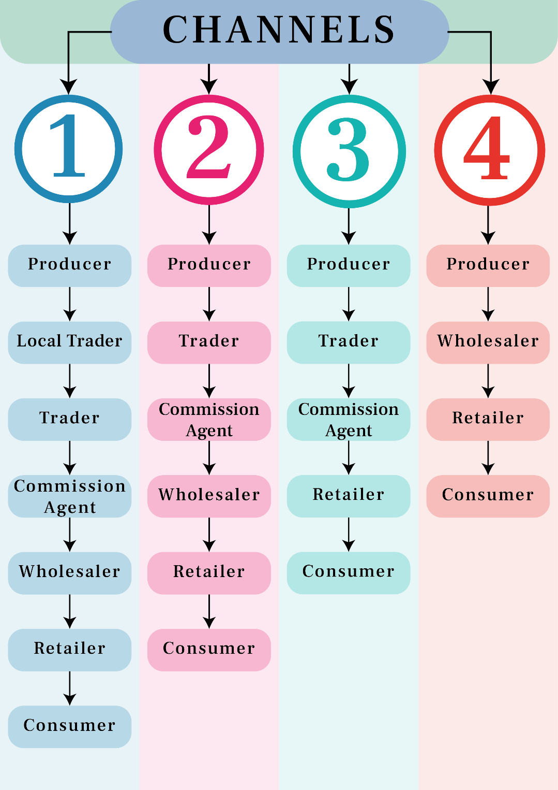

**Fig 8.** Marketing Channel of *Nappi* in Bangladesh

Value chains describe the activities that lead from raw materials to the final consumer [34, 35]. It involves activities such as production, marketing, distribution, competitive analysis, flexibility, quality maintenance, and identifying unique opportunities and solutions. Traditionally, the value chain includes the producer, the processor, the wholesaler, the exporter, the importer, the retailer, and the consumer. This helps to understand the flow of goods and services up and down the chain, as well as between different chains.

In summary, the value chain is the sequence of activities, the key participants, and the relationship between them. In Figure 7, the top row indicates the various functions of the actors involved in the production, collection, wholesale, retail, and consumption of *Nappi.* Similarly, on the right side of the figure 9, it is shown that the stakeholders are involved and how the products are flowed between them.

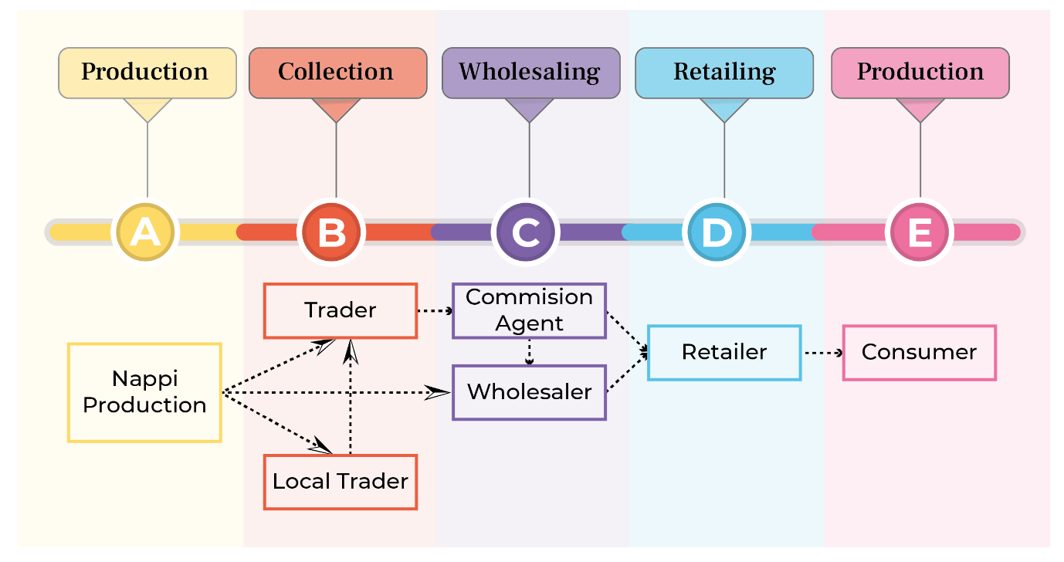

**Figure 9.** Value Chain of *Nappi* in Domestic Market of Bangladesh

**4. Conclusions and Recommendations**

Upon reviewing the results of the present study, we are able to conclude that the highest percentage of protein contained in the Chaufaldandi sample is due to the presence of good quality raw materials with low moisture content. It may be possible to enhance the quality of the *Nappi* produced on Maheshkhali Island by decreasing its moisture content. *Nappi* is a seasonal product. In light of the fact that the products are produced very locally, there is a great need for *Nappi* processing facilities and technologies to be improved. The addition of improved processing facilities can increase the consumer's willingness to consume the product as well as enhance its shelf life. In addition, it is important to develop and distribute low-cost storage technologies to the producers.

Due to the availability of raw materials in the coastal area of Bangladesh, *Nappi* is traditionally produced, but has a great deal of demand among indigenous peoples of the districts, such as Cox’s Bazar, Rangamati, Khagrachari, Bandarban, Patuakhali, etc. In order to improve the quality and value of *Nappi,* proper sanitary and hygiene techniques must be followed during the production process. Currently, this product is exported to our neighboring country Myanmar via the internal trade route. However, improved *Nappi* can take the potential international market to south-east Asian countries like the Philippines, Malaysia, Indonesia, Thailand, Hong Kong etc. Proper authorities should come forward to make an intervention on proper preparation techniques, storage facilities and to develop proper marketing channel for *Nappi* in Bangladesh to get national and international attention to highlight this ethnic food item.

**Declarations**

**List of abbreviations**

Not applicable

**Ethics approval and consent to participate**

Not applicable

**Availability of data and materials**

The datasets during and/or analysed during the current study are available from the corresponding author upon reasonable request.

**Competing interests**

The authors declare that they have no competing interests.

**Consent for publication**

The published version of the article has been reviewed and approved by all authors.

**Funding**

This research received no external funding.

**Authors' contributions**

MMM: conceptualization, methodology, editing, reviewing, and supervision; MRI: reviewing and editing; SDN: data collection, data analysis, and writing; MAAK: editing, reviewing, and supervision; MSA: editing and reviewing; AA: data analysis and visualization; IA: data analysis, visualization, and reviewing.

**Acknowledgement**

The authors would like to thank the local community on Chaufaldandi and Maheskhali Island for their assistance with the collection of samples.

**References**

1. Alam SMN & Naser MN. Role of traditional foods of Bangladesh in reaching-out of nutrition. In Nutritional and Health Aspects of Food in South Asian Countries (Issue January 2020). Nutritional & Health Aspect-Traditional & Ethnic Food. 2020; 217-235. <https://doi.org/10.1016/b978-0-12-820011-7.00025-3>.
2. Naroll R. On Ethnic Unit Classification. Current Anthropology.1964; Vol. 5, No. 4, pp. 283-312.
3. Pandey R, Jha SK, Alatalo JM, Archie KM & Gupta AK. Sustainable livelihood framework-based indicators for assessing climate change vulnerability and adaptation for Himalayan communities. Ecological Indicators. 2017; 79, 338–346. <https://doi.org/10.1016/j.ecolind.2017.03.047>.
4. Siraj N, Bal E, & Sinha-Kerkhoff K. ‘This Is (Not) a Love Story’: Negotiating Belonging, Community, and Interethnic Marriages in the Chittagong Hills of Bangladesh. In The Price of Belonging: Perspectives from Asia. 2023, pp. 102-121. Brill.
5. Uddin ME. "Disparity in family status attainment between the majority and minority ethnic groups in Bangladesh", International Journal of Social Economics. 2017, Vol. 44 No. 4, pp. 530-546. https://doi.org/10.1108/IJSE-07-2015-0187 .
6. Chakma N & Maitrot M. How ethnic minorities became poor and stay poor in Bangladesh: A qualitative enquiry. 2016, EEP/Shiree, July. DOI:[10.13140/RG.2.2.11954.25289](http://dx.doi.org/10.13140/RG.2.2.11954.25289).
7. Haque M. Rights of the Ethnic Minorities under International Law: A Legal Monograph on Bangladesh and South Asia’ (2019) 7(2) Kathmandu School of Law Review 57 MLA 9th ed. Haque, Md. Tanzimul, and Zeba Farah Haque. Rights of the Ethnic Minorities under International Law: A Legal Monograph on Bangladesh and South Asia. 2019, 57(2), 57–70. <https://doi.org/10.46985/kslr.v7i2.1209>.
8. Chakma T, Sarker BS, Majumdar PR, Saha D, Hoque AA & Hossain MB. Comparisons of human pathogenic microorganisms in fresh and stored ‘*Nappi*’(Fish-Paste)-An ethnic foodstuff of Bangladesh. World Journal of Dairy & Food Sciences. 2015, 10(1), 60-67. DOI: <http://doi.org/10.5829/idosi.wjdfs.2015.10.1.92173>.
9. Kim YB, Choi YS, Ku SK, Jang DJ, Ibrahim H H. binti & Moon KB. Comparison of quality characteristics between belacan from Brunei Darussalam and Korean shrimp paste. Journal of Ethnic Foods. 2014, 1(1), 19–23. <https://doi.org/10.1016/j.jef.2014.11.006>.
10. Mizutani T, Kimizuka A, Ruddle K & Ishige N. Chemical components of fermented fish products. Journal ofFood Composition and Analysis. 1992, 5(2), 152-159. <https://doi.org/10.1016/0889-1575(92)90031-E>.
11. Jinap, S., Ilya-Nur, A. R., Tang, S. C., Hajeb, P., Shahrim, K., & Khairunnisak, M. (2010). Sensory attributes of dishes containing shrimp paste with different concentrations of glutamate and 5′-nucleotides. Appetite, 55(2), 238-244.
12. Ruddle, K., & Ishige, N. (2010). On the origins, diffusion and cultural context of fermented fish products in Southeast Asia. Globalization, food and social identities in the Asia Pacific region, 1-17.
13. Suhartini W, Yang F & Xia W. Physiochemical Properties, Volatile Compounds and Sensory Evaluation of Chili Sauce Shrimp Paste from Different Regions in Indonesia. Food and Nutrition Sciences. 2019, 10, 333-348. <https://doi.org/10.4236/fns.2019.103026>.
14. Thapa N, Pal J & Tamang JP. Microbial diversity in *ngari, hentak and tungtap*, fermented fish products of North-East India. World Journal of Microbiology and Biotechnology. 2004, 20(6), 599–607. <https://doi.org/10.1023/B:WIBI.0000043171.91027.7e>.
15. Kakati BK & Goswami UC. Microorganisms and the Nutritive Value of Traditional Fermented Fish Products of Northeast India. Global Journal of Bioscience and Biotechnology. 2013, 2(1), 124–127.
16. Şanlie N, Gökcen BB & Sezgin AC. Health benefits of fermented foods. Critical Reviews in Food Science and Nutrition. 2019, 59(3), 506–527. <https://doi.org/10.1080/10408398.2017.1383355>.
17. Freije A & Mohamed Alkaabi A . Fatty Acid Compositions in Fermented Fish Products. Advances in Lipid Metabolism. 2020, 1–14. <https://doi.org/10.5772/intechopen.90110>.
18. Han SC, Kang GJ, Ko YJ, Kang HK, Moon SW, Ann YS & Yoo ES. Fermented fish oil suppresses T helper 1/2 cell response in a mouse model of atopic dermatitis via generation of CD4+CD25+Foxp3+ T cells. BMC Immunology. 2012, 13, 1–12. <https://doi.org/10.1186/1471-2172-13-44>.
19. Majumdar RK, Bejjanki SK, Roy D, Shitole S, Saha A & Narayan B. Biochemical and microbial characterization of Ngari and Hentaak - traditional fermented fish products of India. Journal of Food Science and Technology. 2015, 52(12), 8284–8291. <https://doi.org/10.1007/s13197-015-1978-x>.
20. Shivanne Gowda SG, Narayan B & Gopal S. Bacteriological properties and health-related biochemical components of fermented fish sauce: An overview. Food Reviews International. 2016, 32(2), 203–229. <https://doi.org/10.1080/87559129.2015.1057844>.
21. Cai L, Wang Q, Dong Z, Liu S, Zhang C & Li J. Biochemical, nutritional, and sensory quality of the low salt fermented shrimp paste. Journal of Aquatic Food Product Technology. 2017, 26(6), 706-718.
22. Rajapakse N, Mendis E, Jung WK, Je JY & Kim SK. Purification of a radical scavenging peptide from fermented mussel sauce and its antioxidant properties. Food Research International. 2005, 38(2), 175-182. <https://doi.org/10.1016/j.foodres.2004.10.002>.
23. Crampton EE & Harris LE. Applied Animal Nutrition, 2nd Edition. L. H. Freeman and Co., San Francisco. 1969.
24. Jacobs MB. The chemical analysis of foods and food products. The chemical analysis of foods and food products., (2nd edition). 1951.
25. Pearson D. The chemical analysis of foods (No. Ed. 7). Longman Group Ltd. 1976.
26. Maynard A. Methods in Food Analysis Academic Press New York. 1970, p 176.
27. Lovell RT. Laboratory Manual for Fish Feed Analysis and Fish Nutrition Studies. Department of Fisheries and Allied Aquaculture, Auburn University, Auburn, Alabama. 1975.
28. Clucas IJ & Ward AR. Post-harvest fisheries development: a guide to handling, preservation, processing and quality. Natural Resources Institute, Chatham, UK. ISBN 08595444191996.
29. Mau KA. Preliminary study on the biochemical composition and microbial load of locally collected *Nappi*. Terminal paper (un published), Institute of Marine Sciences, University of Chittagong, Bangladesh. 2012.
30. Montaño N, Gavino G & Gavino V. Polyunsaturated fatty acid contents of some traditional fishand shrimp paste condiments of the Philippines. FoodChemistry. 2001, 75(2). <https://doi.org/10.1016/S0308-8146(01)00126-1>.
31. Ilyanie HY, Huda-Faujan N & Ida-Muryany MY. Comparative Proximate Composition of Malaysian Fermented Shrimp Products. Malaysian Applied Biology. 2020, 49(3), 139-144.
32. Hajeb P & Jinap S. Fermented Shrimp products as source of umami in Southeast Asia. Journal of Nutrition and Food Sciences. 2012. <https://doi.org/10.4172/2155-9600.S10-006>.
33. Kohls RL & Uhl JN. Marketing of agricultural products (No. Ed. 9). Prentice-Hall Inc. 2002.
34. Walters D & Lancaster G. Implementing value strategy through the value chain. Management Decision. 2000, 38(3), pp.160-178.
35. Jacinto ER. A research framework on value chain analysis in small scale fisheries. In 10th Biennial Conference of the International Association for study of common property, Oaxaca, Mexico. 2004, Vol. 27, pp. 9-13.